Bern, Switzerland: Sensogram(tm) - a Swiss-Made New Product for Patient Vitals Mobile Monitoring by Sensogram Technologies AG

A breakthrough technology implemented in a tiny mobile device allowing to monitor patient's vital signs and other biomedical parameters remotely and continuously, giving the user a freedom and a choice of the lifestyle, while giving the doctor the full pattern of changes and trends of vital signs and other monitored parameters. Being in high demand by the medical, wellness, and sports communities, the first products - Sensogram and SensoTRACK have been successfully demonstrated at the WMTF 2013 in Lucern by the team of Sensogram Technologies AG.
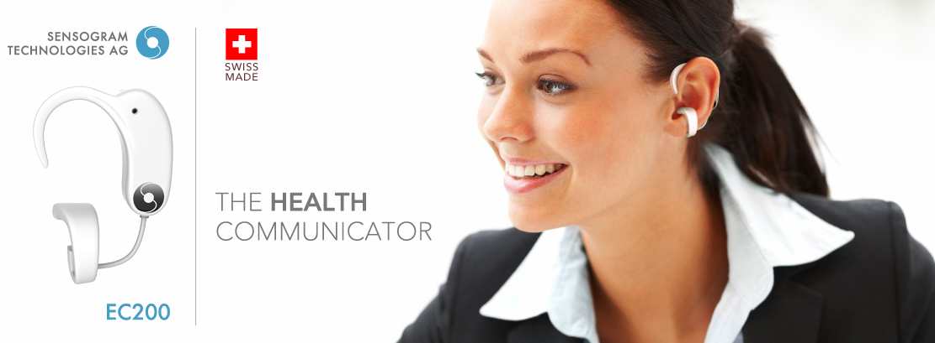
Lucerne, Switzerland October 21, 2013
World novelty at the World Medtech Forum, Lucerne 2013: Sensogram Technologies AG presents its non-invasive device for continuous measurement of blood pressure, respiration rate and other vital parameters.
At the World Medtech Forum in Lucerne (WMTF 2013) this year, Berne-based Sensogram Technologies AG successfully demonstrated its new product for remote patient monitoring.
This unique device allows monitoring patients’ blood pressure, respiration rate, oxygen saturation, heart rate and other biomedical parameters remotely and continuously.
Doctors or nurses can remotely set the thresholds of required monitoring parameters allowing patients to be monitored while enjoying the freedom of the chosen lifestyle.
The breakthrough medical technology for cuff-less measurement of blood pressure and other vital functions is a result of five years of international research and development.
Sensogram products are designed, integrated and manufactured in Switzerland. This has made Sensogram one of the leading Swiss companies in the increasingly popular field of remote patient monitoring. Sensogram EC-200 has been qualified as a Class 1 non-invasive medical device and it is currently being tested for a CE mark and FDA 510(k) certification.
"A unique blend of expertise in micro-technology and cardiology is critical to the success of Sensogram. Our entire team is proud to offer an affordable and very convenient device, which allows medical consultants to administer their patients worldwide. With the Sensogram technology nurses can intervene in case of need – being it emergency or instant consultation," said the founder and CEO Dr. Vahram Mouradian in an interview.
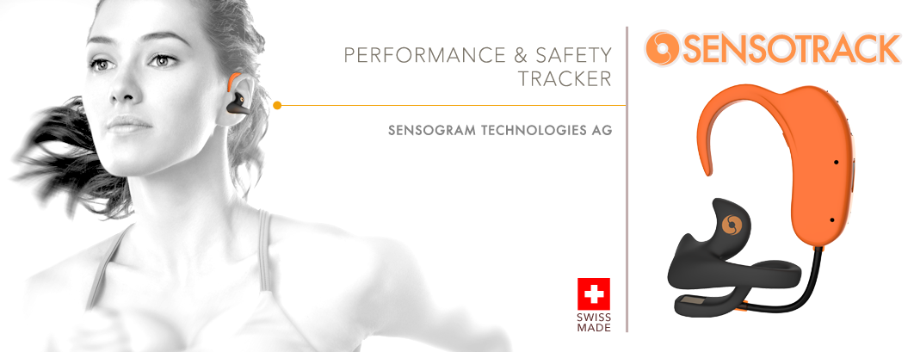
"I am glad that we could persuade Sensogram to choose Switzerland for their international headquarters," said Patrick Roth, CCMT Switzerland General Manager. "Breakthrough technologies like Sensogram is offering can help improve the quality of medical care and therapy at no additional cost."
The fact that Sensogram Technologies AG has based its production in Switzerland is yet another recognition of Swiss quality and competitiveness," continued Mr. Roth.
SensoTRACK™ activity and performance monitor, the first product of Sensogram Technologies AG, will roll out in the European markets in early 2014.
Further inquiry
In case of questions or further inquiries, please contact Ms. Karin Roth at karin(at)sensogram(dot)com.
Sensogram Technologies AG
Karl-Neuhaus Strasse 8
CH-2502 Biel/Bienne
http://www.sensogram.com

