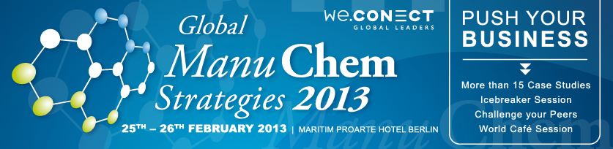
Global ManuChem Strategies 2013
Challenges & solutions in organizational implementation of end-to-end processes in the chemical industry and impact on effective process management
25th – 26th February 2013 / Maritim Pro Arte Hotel Berlin / Germany
http://manu-chem2013.we-conect.com/en/

The Global ManuChem Strategies 2013 Conference is already in one month! With more than 100 leading opinion makers and industry experts it will be the leading event about process management in the chemical industry. Here are some hints of exciting speakers and interesting subjects we have prepared for you.

TOP STORIES 2013
Short summaries of our keynote speakers’ presentations for the Global ManuChem Strategies 2013 conference

- Luca Rosetto, Corporate Vice President Corporate Operations & Responsible Care, DSM / Netherlands will explain how to translate a company’s Business Strategy into an Operations’ strategy. Moreover, it will include discussion of how to embed this Operations strategy into different Business Units. How to deploy the Business Units’ Operations strategy to sites. And finally, how to bring strategy down to the shop floor.

- Dr. Dirk Holbach, Corporate Vice President International Production, Henkel AG & Co. KGaA / Germany is discussing with a World Café Session how does sustainability actually deliver value & how can we translate sustainable manufacturing operations into genuine business value for profitable growth. Moreover, how to align sustainable goals with corporate objectives and how focusing on customer requirements can deliver sustainable products will be discussed. Lastly, leveraging sustainability as an entrepreneurial activity across the value chain and implementing a sustainable thinking culture approach at the shop floor will be reviewed.

- Gerd Pösch, General Manager Operations Sasol O&S, Sasol / Germany will showcase the long term maintenance & plant asset management development as an element of operations excellence. Furthermore the maintenance excellence as one major element of Operations Excellence (beside Energy, Process Control / APC and Project Management) will be viewed closely. A discussion about asset strategy & asset management for improved availability and early problem detection together with short maintenance downtimes is held. In the end, question how to move from cost cutting to long term maintenance improvement planning to maintenance excellence and overall cost reduction is treated.

Moreover, to find the most feasible way to optimize your business processes take a look in our media center, where you can find material from significant players in this field.

TOP 3 ARTICLES 2012
Short appetizers, to gain further insights of what our solution providers have in store for you..

ABB Consulting – Achieving operational excellence
Looking for to improve your business operations? ABB Consulting helps customers achieve operational excellence. “We identify and implement pragmatic solutions based on technical excellence and industry expertise.” Lower operational risks, optimal operational cost, greater efficiency and greater capital productivity of assets are typical areas of customer benefits ABB is focused on. “Our approach to improvement comes in 3 stages and, as appropriate to the situation, can support all stages or focus on particular improvement stages only.” By having specialist engineers in all disciplines and consultants with global operational backgrounds, ABB can work across all areas of operations, as well as start with an area of particular concern or opportunity..
Read more about ABB´s 3-stage approach to improvement and ways of working when it comes to delivering efficient results for their customers: http://manu-chem2013.we-conect.com/en/preview/media-center/

ABB Consulting – Solutions: Life extension studies
“In principle, modern alarm systems provide process operators with an essential tool in managing plant operations and minimizing unplanned abnormal events, such as plant outage or equipment damage. In the multiple lines of defense of any process plant, they provide an invaluable layer of protection, combining the flexibility and adaptability of the plant operator with the power of technology.”
Read more about the alarm systems and process safety with ABB: http://manu-chem2013.we-conect.com/en/preview/media-center/

ConMoto – Value Oriented Maintenance: The strategic dimension of the spanner
“Do you know the feeling? You prepare yourself for a demanding mountain hike, a marathon or a transalpine on your mountain bike. You train, train and train without feeling that you're getting anywhere? Good intentions and back-breaking effort alone only lead to the desired level of performance by chance. If you want to reach your best form, however, you initially need a comprehensive performance diagnosis and, building on this, an individually oriented training concept based on specialist knowledge.”
Take a closer look on how top business performances are achieved with ConMoto here: http://manu-chem2013.we-conect.com/en/preview/media-center/

We are looking forward to welcome you at the Global ManuChem Strategies 2013 from the 25th to the 26th February 2013 in Berlin.

Peter Haack

Marketing Development Manager

we.CONECT Global Leaders GmbH

Gertraudenstr. 10-12 | 10178 Berlin, Germany

Phone: +49 (0)30 52 10 70 3 - 55 | Fax: +49 (0)30 52 10 70 3 - 30

Email: peter.haack@we-conect.com

www.we-conect.com

